Practical 3
Aim
To create and configure a virtual machine using VMware Workstation and install the Ubuntu 20.04.6 Desktop operating system using an ISO image.
Requirements
- VMware Workstation
- ubuntu-20.04.6-desktop-amd64.iso
- A computer with sufficient RAM and free disk space
- Internet connection (optional, but useful during Ubuntu installation)
Suggested VM Configuration
Setting | Recommended value
Guest OS | Linux
Version | Ubuntu 64-bit
VM Memory | 4 GB
Processors | 2 cores
Virtual Disk | 25–30 GB
Network | Bridged
ISO | ubuntu-20.04.6-desktop-amd64.iso
If your computer has limited RAM, you can use 2 GB RAM instead of 4 GB.
Procedure
1. Open VMware Workstation
- Launch VMware Workstation.

- Click Create a New Virtual Machine. 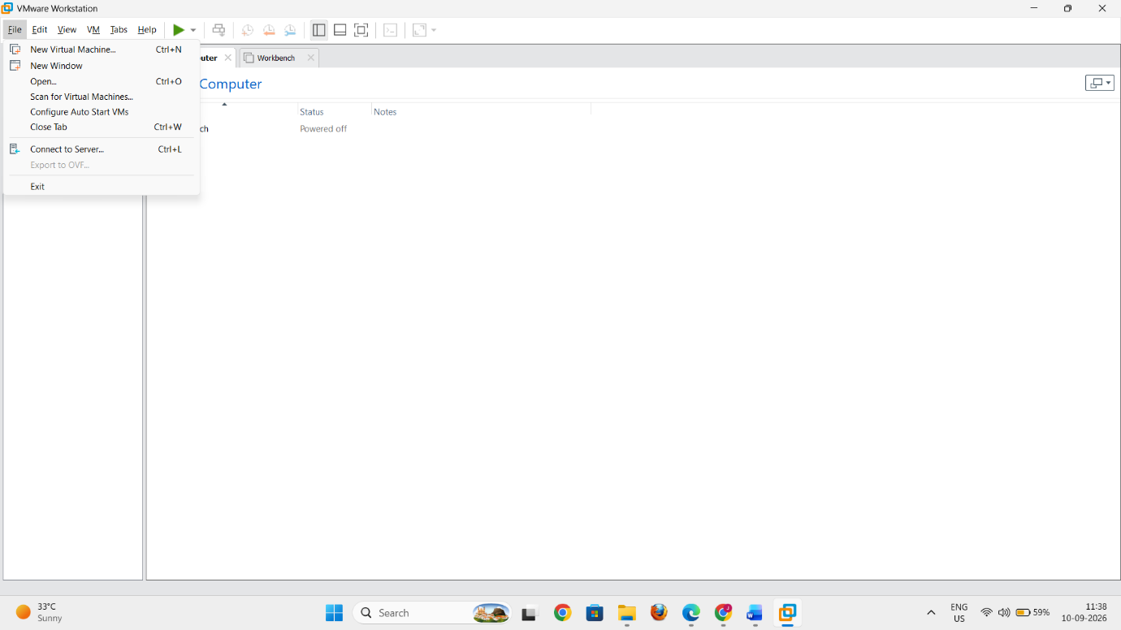
2. Select the Virtual Machine Configuration
- Select Typical (recommended).
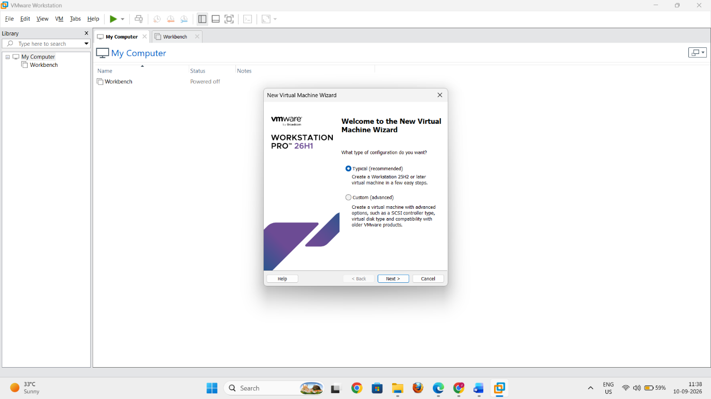
- Click Next.
3. Choose When to Install the Operating System
In the Guest Operating System Installation screen:
- Select I will install the operating system later.
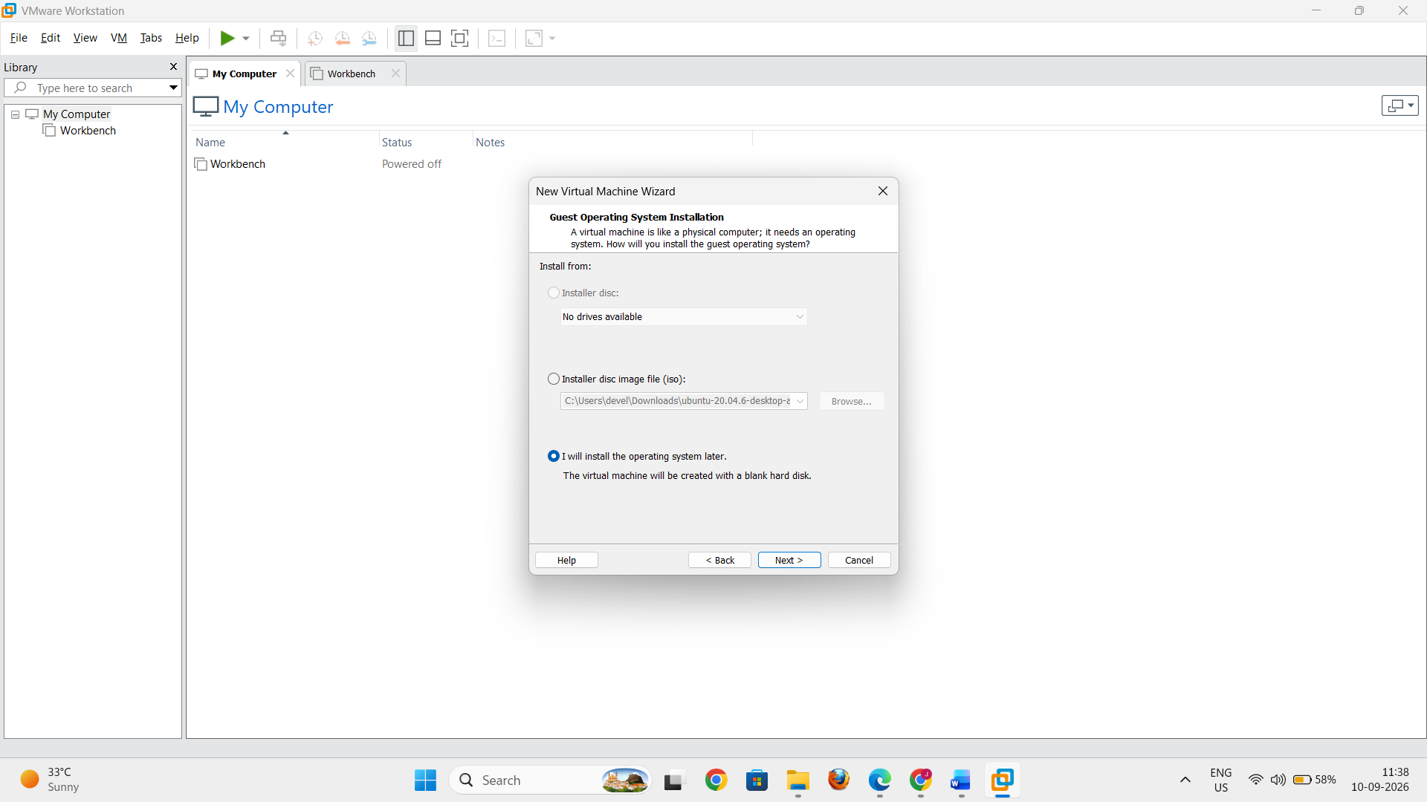
- Click Next.
This creates the virtual machine first without immediately attaching the Ubuntu ISO.
4. Select the Guest Operating System
In the Select a Guest Operating System screen:
- Select Linux.
- For the version, select Ubuntu 64-bit.
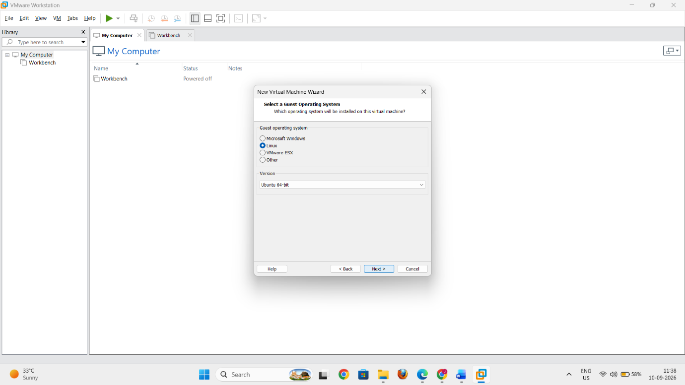
- Click Next.
5. Name the Virtual Machine
In the Name the Virtual Machine screen:
- Enter the virtual machine name:
POV-Lab
- Select a suitable location where the VM files will be stored.
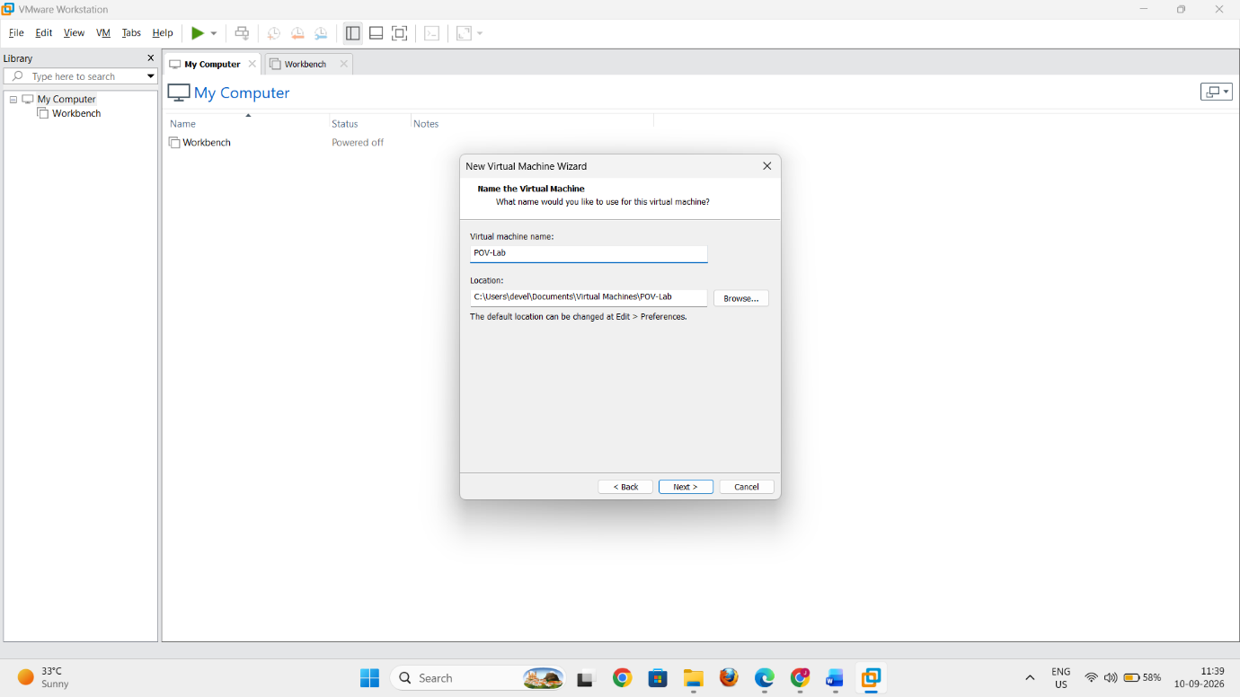
- Click Next.
6. Specify the Virtual Disk Capacity
- Set the maximum disk size to approximately 25–30 GB.
- Select:
Store virtual disk as a single file.
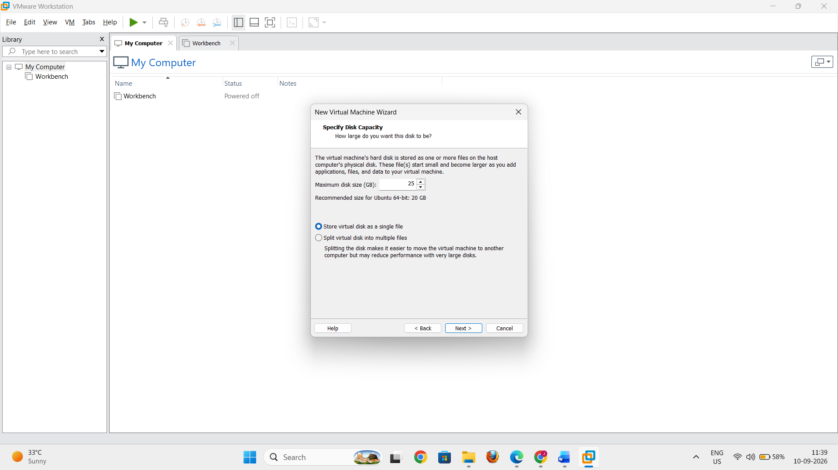
- Click Next.
7. Review the Virtual Machine Settings
Review the configuration.
The VM should have a name similar to:
POV-Lab
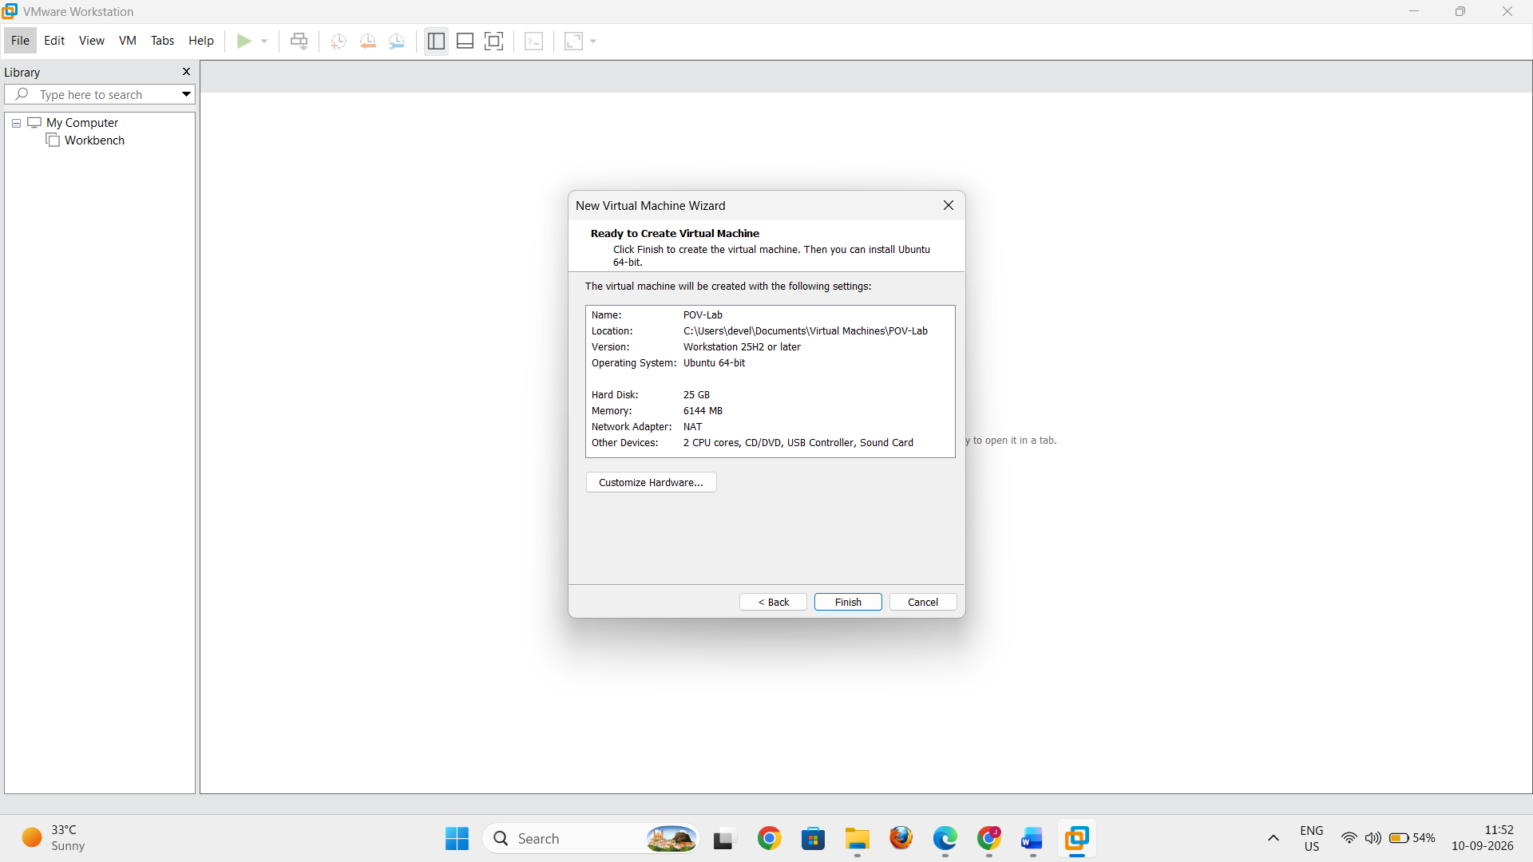
Click Finish to create the virtual machine.
8. Configure the Virtual Machine Hardware
After the VM has been created:
- Select POV-Lab in VMware Workstation.
- Click Edit virtual machine settings.
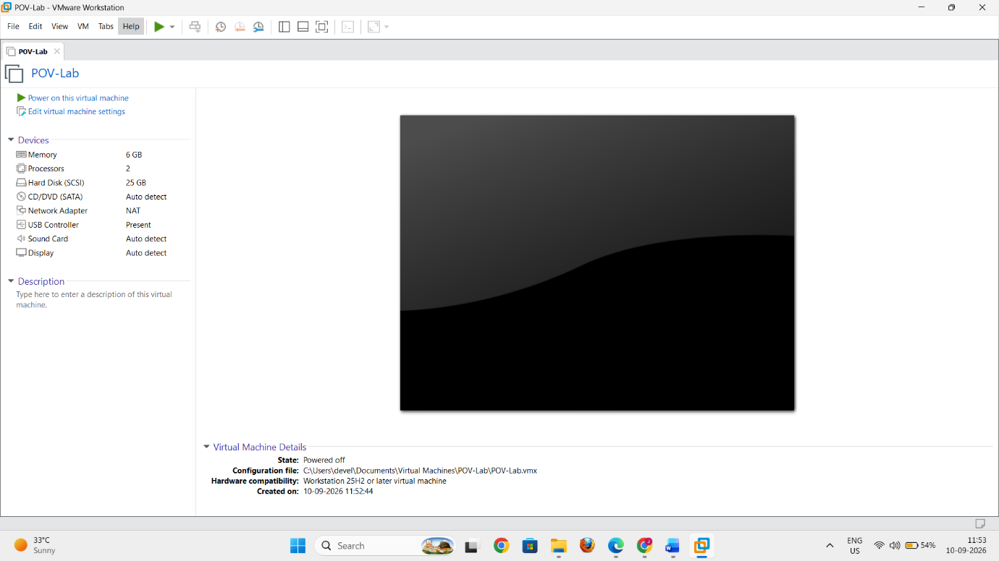
Memory
- Select Memory.
- Allocate 4 GB (4096 MB) of RAM.
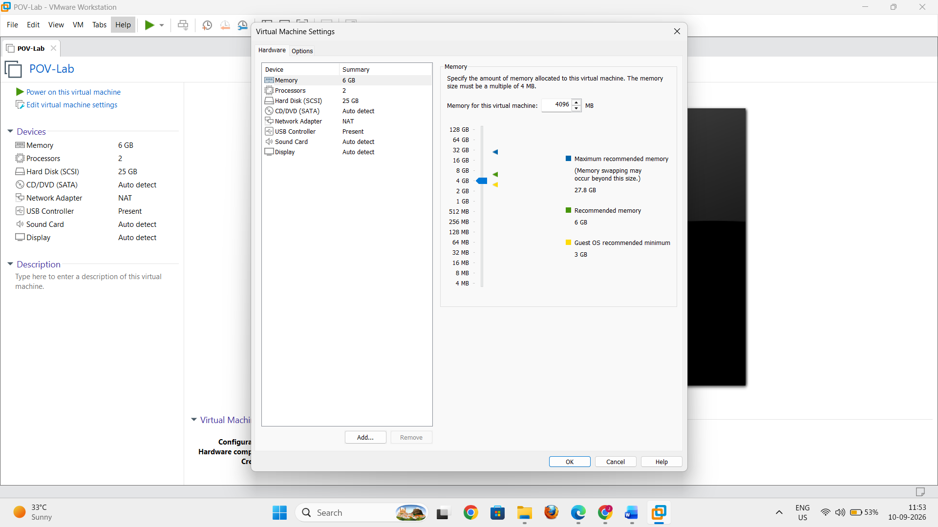
Processor
- Select Processors.
- Allocate 2 processor cores.
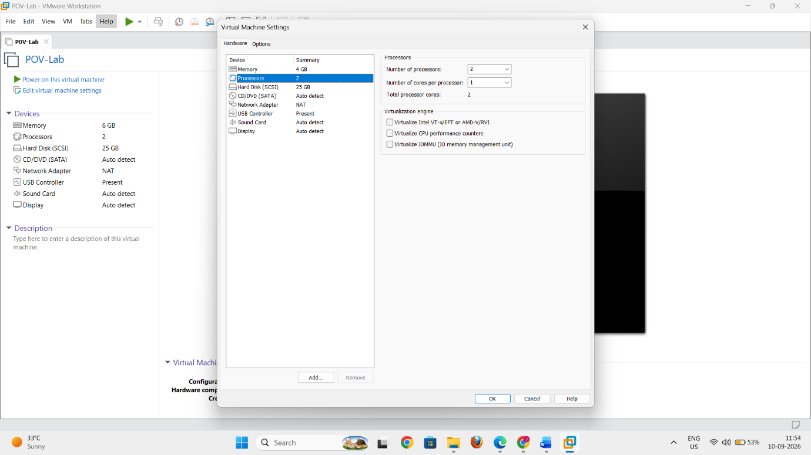
Network Adapter
- Select Network Adapter.
- Select:
Bridged: Connected directly to the physical network
- Make sure Connected and Connect at power on are enabled.
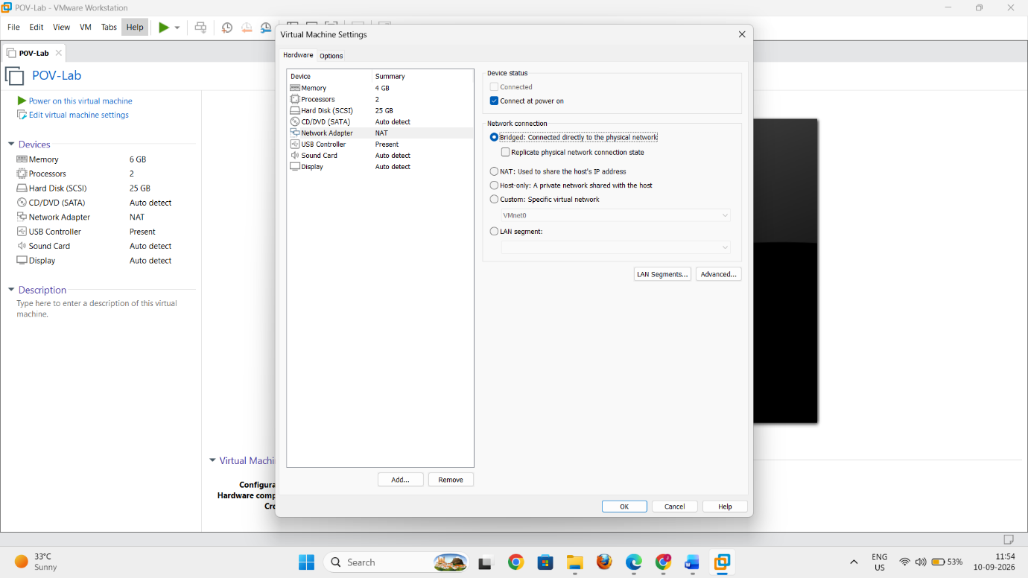
CD/DVD Drive
Since we chose “I will install the operating system later”, the Ubuntu ISO needs to be attached manually.
- Select CD/DVD (SATA).
- Select Use ISO image file.
- Click Browse.
- Locate and select:
ubuntu-20.04.6-desktop-amd64.iso
- Make sure Connect at power on is enabled.
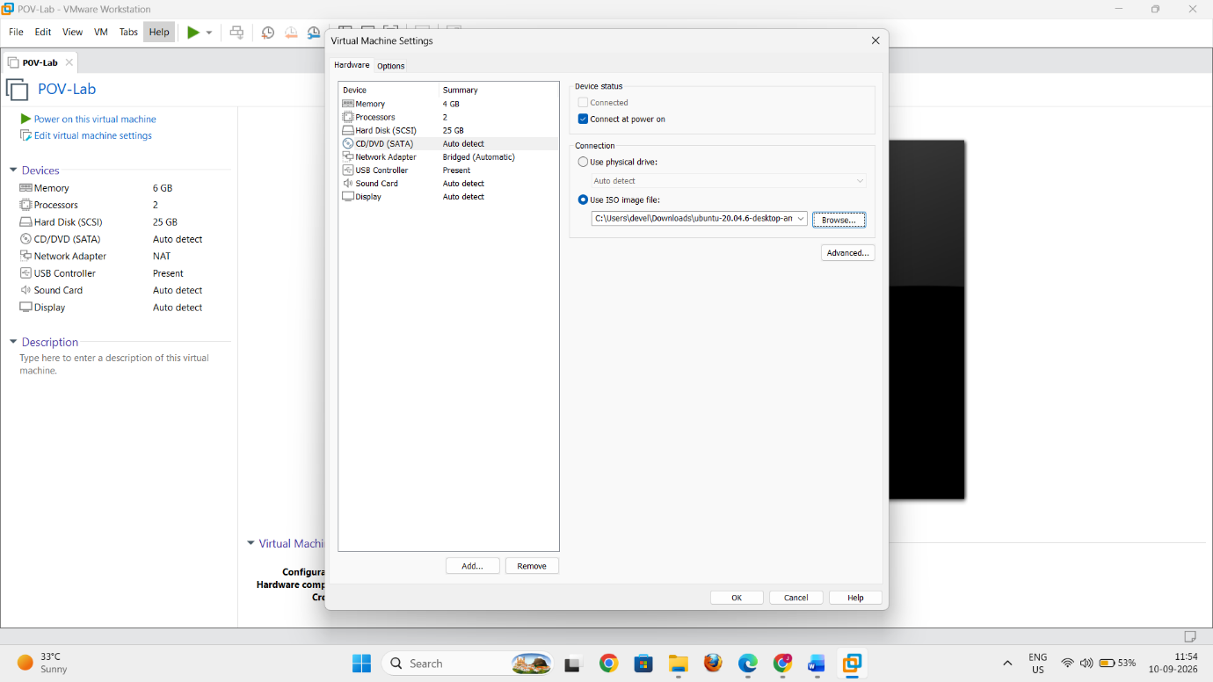
Click OK to save the settings.
9. Start the Virtual Machine
- Select POV-Lab.
- Click Power on this virtual machine.
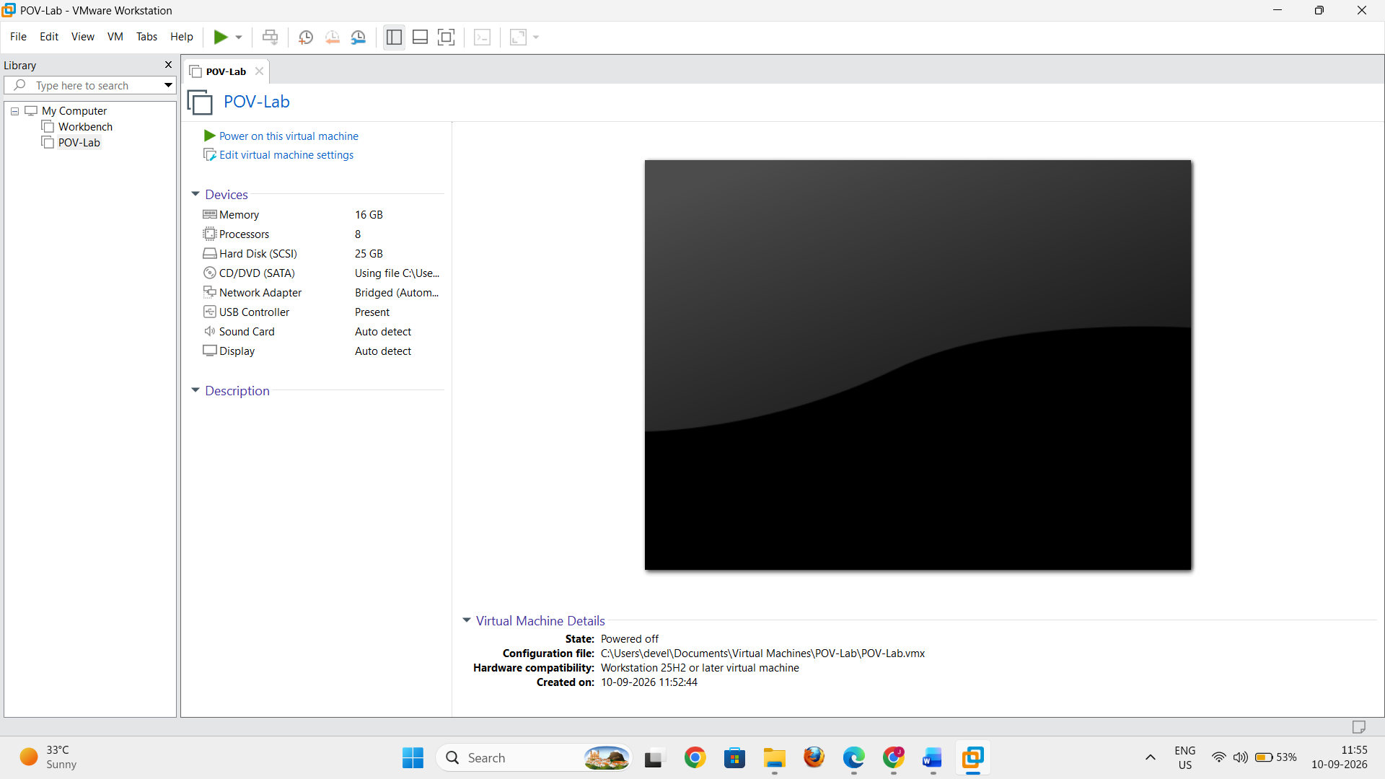
VMware will boot the VM using the Ubuntu ISO attached to the virtual CD/DVD drive.
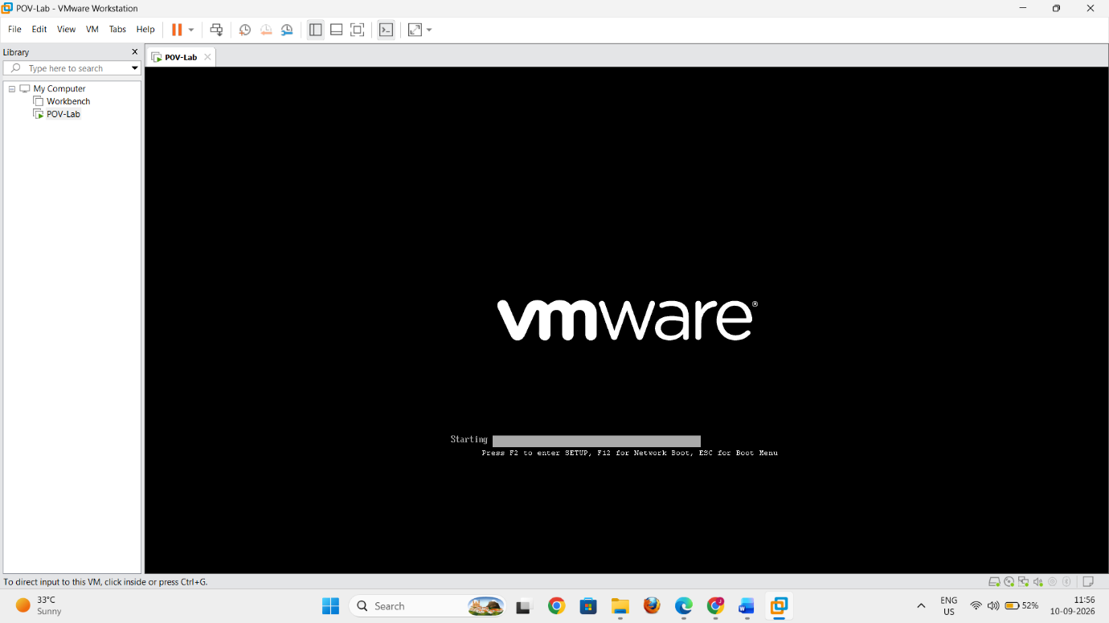
10. Start Ubuntu Installation
When the Ubuntu installation screen appears:
- Select Install Ubuntu.
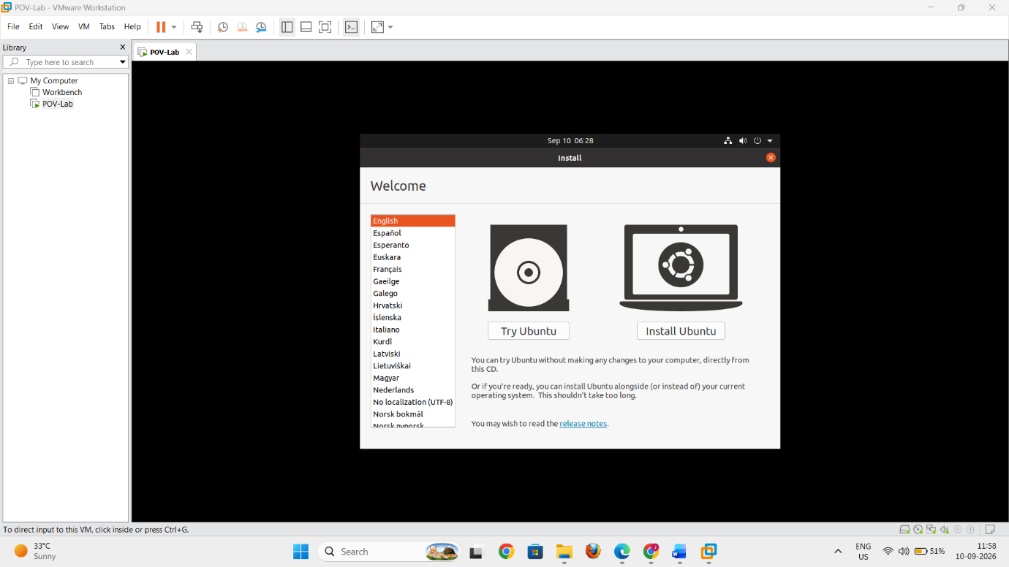
Follow the installation wizard.
Keyboard Layout
- Select your preferred keyboard layout.
- Click Continue.
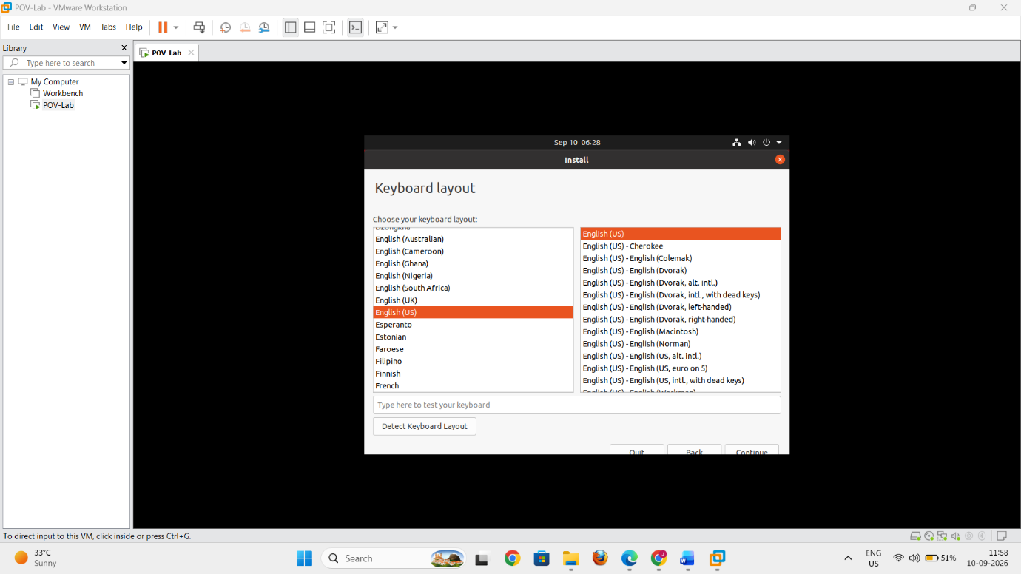
Updates and Other Software
Select:
Normal installation
You may also select the option to download updates during installation if an Internet connection is available.
Click Continue.
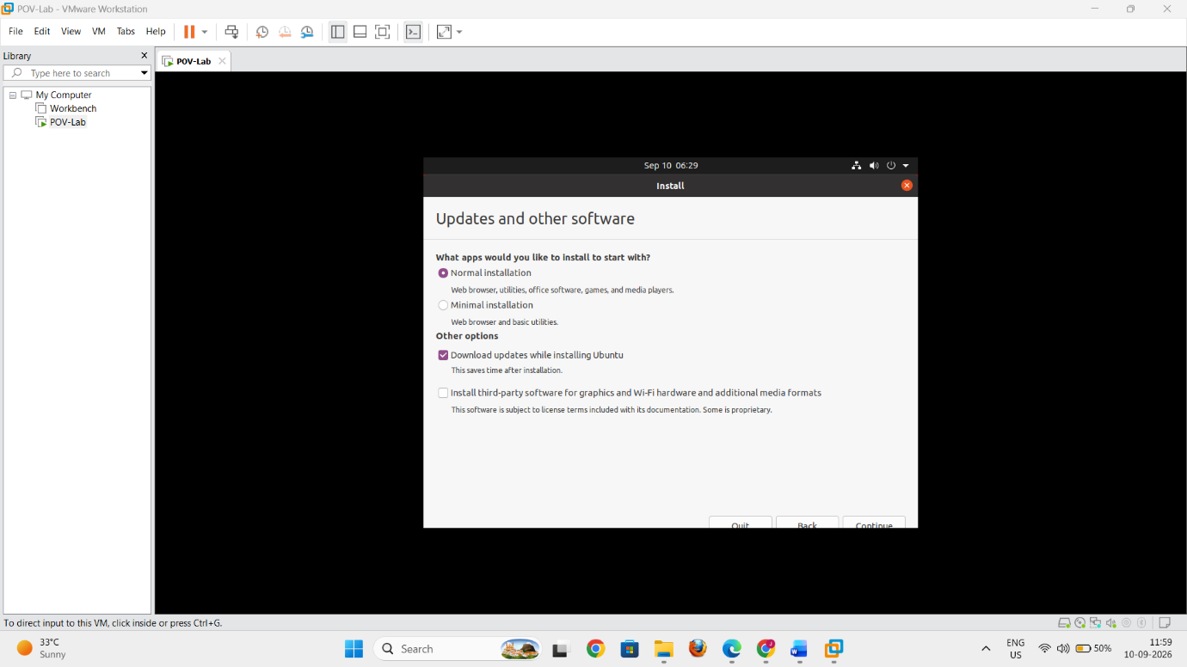
Installation Type
Select:
Erase disk and install Ubuntu
Then click Install Now.
Important: This erases the virtual disk belonging to POV-Lab, not the physical hard drive of your computer.
Confirm the changes when prompted.
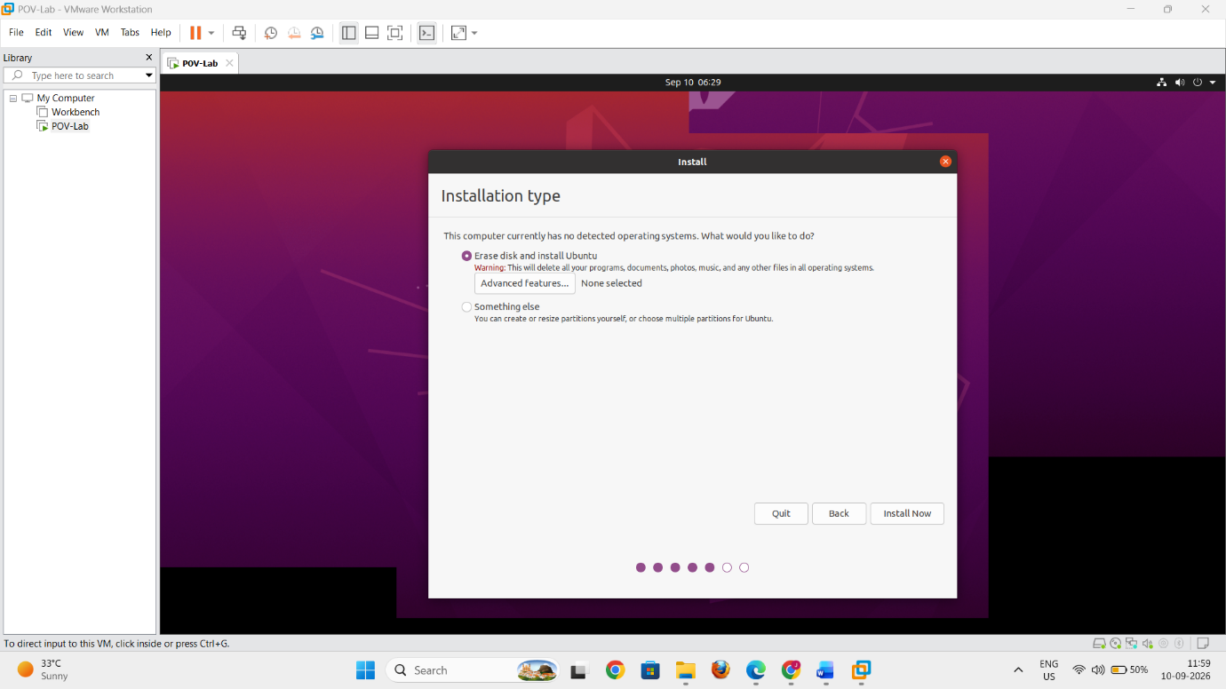
11. Select Time Zone
- Select your appropriate location/time zone.
- Click Continue.
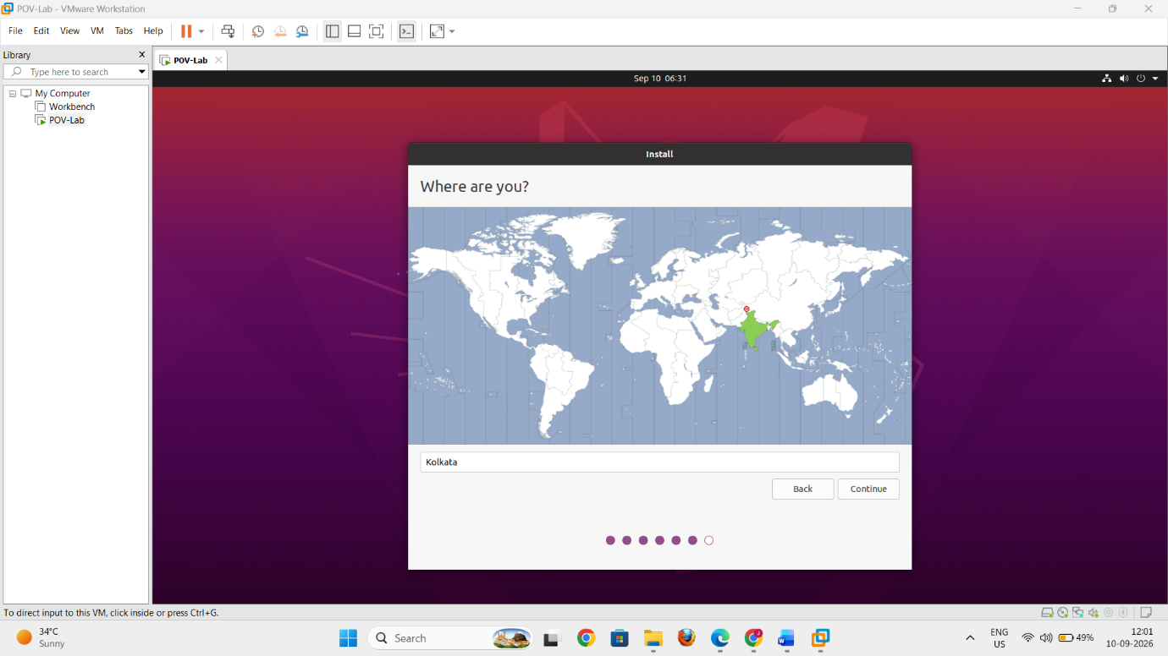
12. Create User Account
Enter the required details:
- Your name
- Computer name
- Username
- Password
Then click Continue.
Ubuntu will begin installing onto the virtual hard disk.
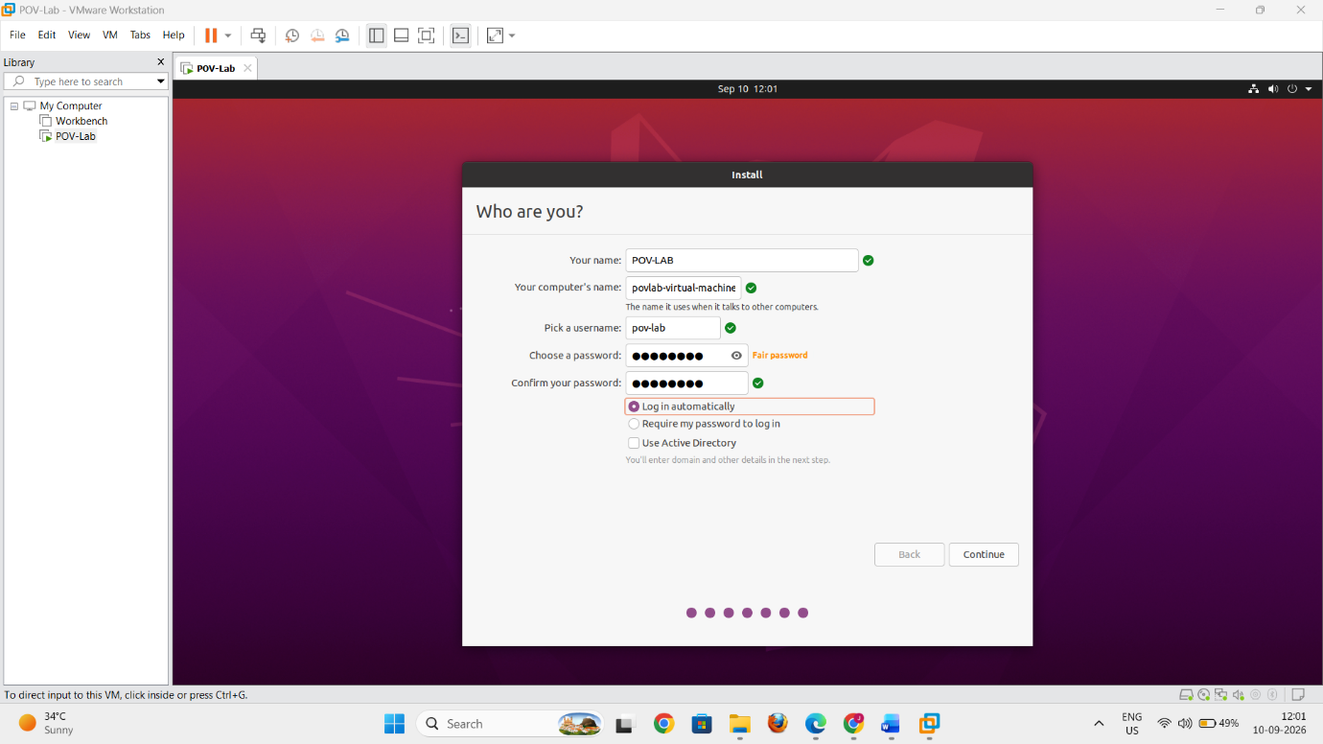
13. Complete the Installation
- Wait for Ubuntu to finish installing.
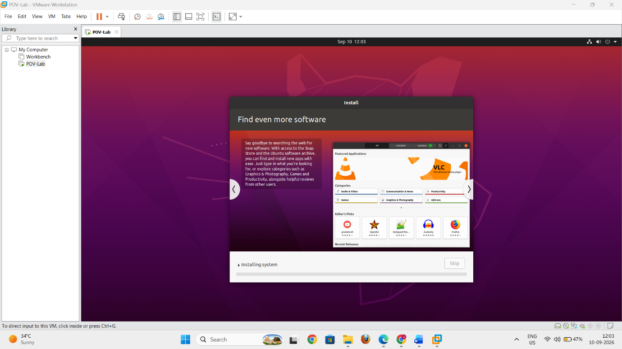
- When installation is complete, click Restart Now.
- If VMware prompts you to remove the installation media, disconnect the ISO/CD-ROM and press Enter.
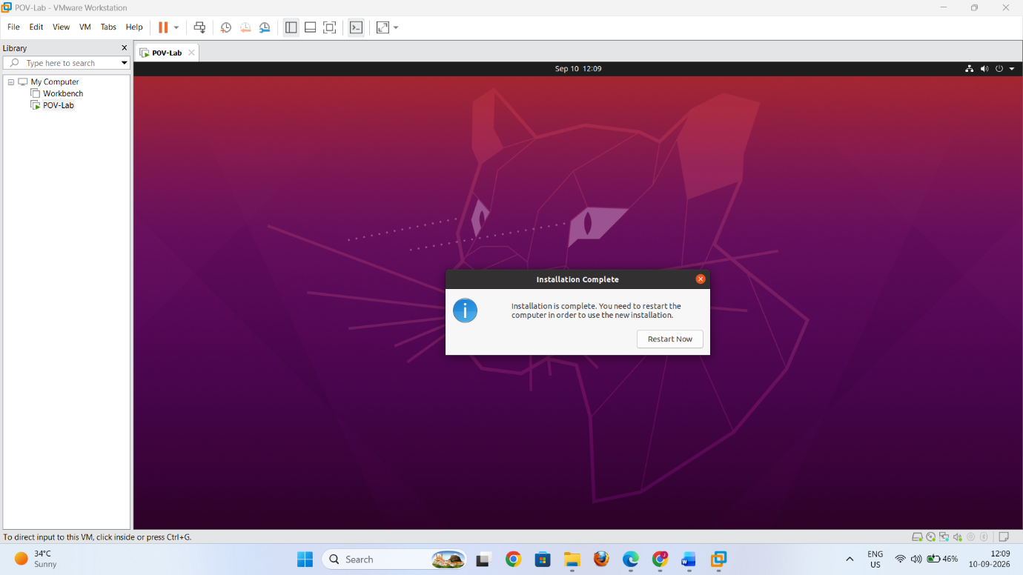
Ubuntu should now boot from the virtual hard disk.
14. Verify the Installation
After Ubuntu starts:
- Log in using the username and password created during installation.
- Open Settings → About.
- Verify that Ubuntu is installed correctly.
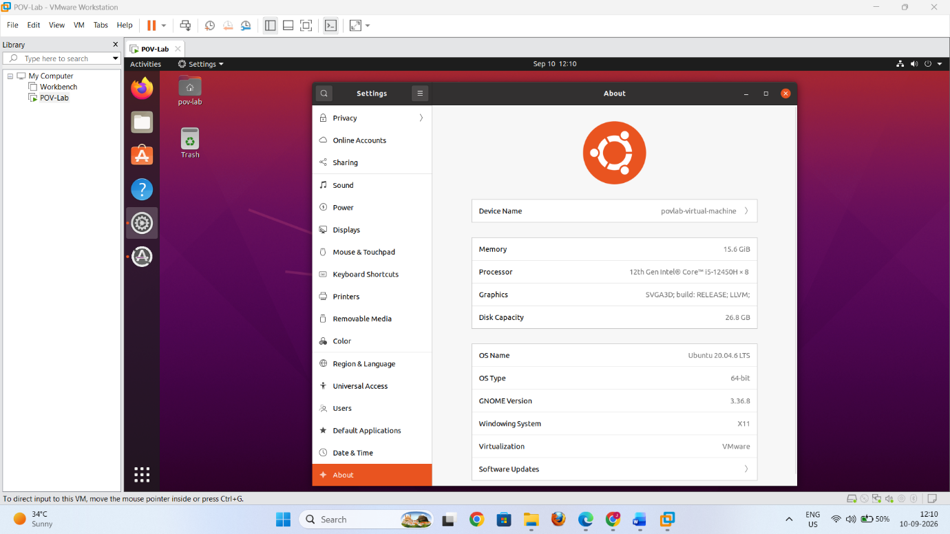
You can also open Terminal and run:
lsb_release -a
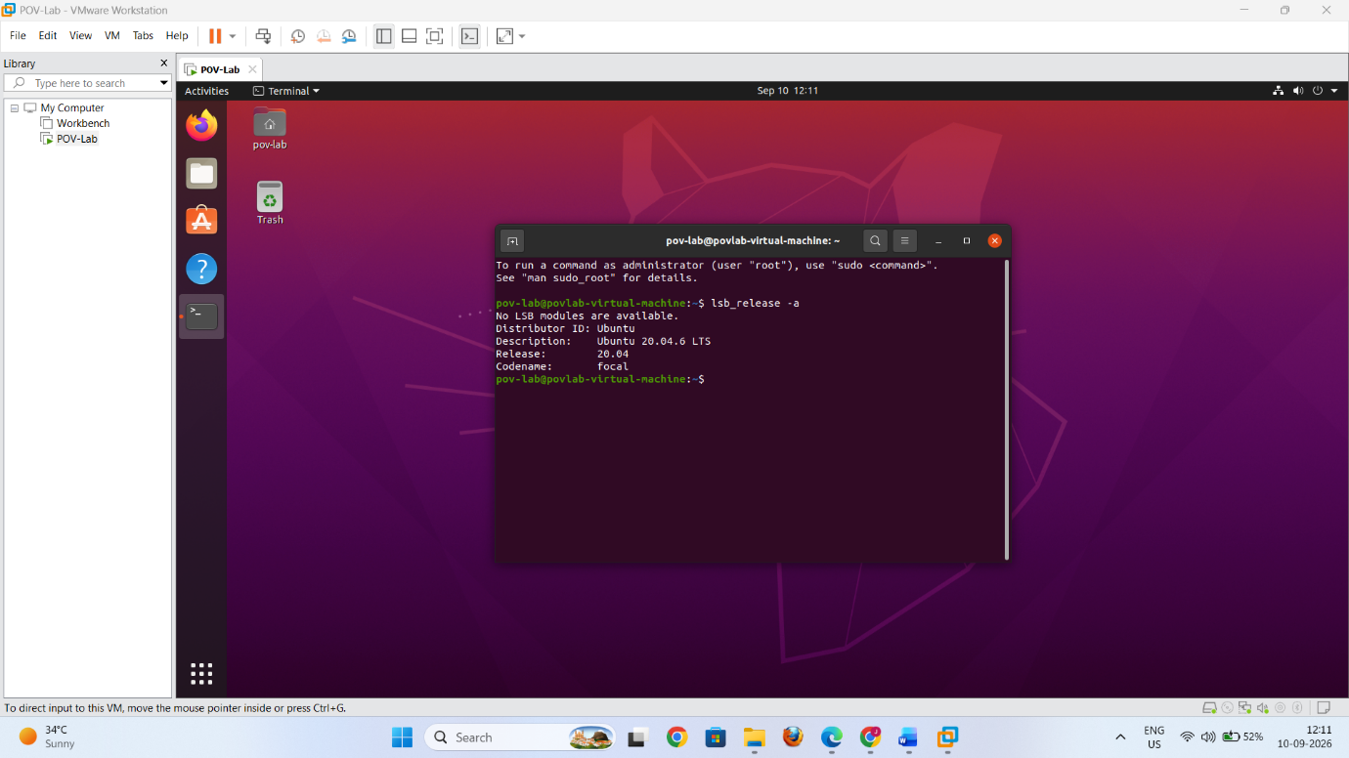
Result
A virtual machine was successfully created and configured in VMware Workstation, and Ubuntu 20.04.6 Desktop was successfully installed using the ubuntu-20.04.6-desktop-amd64.iso image.

